Credit Risk Modelling

Problem Definition:

Every bank needs to maintain a certain amount of liquid capital which could be used in case of emergency. The revenue of the bank depends upon its capability to rotate the money in the market which can be done in form of loans. The interests levied on these loans act as a source of income for the bank so we want to maximize our loan providing capability but also make sure that we do not give out the loan to parties which poses a high risk of default.

The objective of this project is to estimate the Expected Loss(EL). The accuracy of this estimate will enable the bank to lend out more and in turn maintain a lower capital of liquid assets lying around with the bank. As per Basel II, this can be calculated based on the formula:

Expected Loss (EL) = Probability of Default (PD) x Loss Given Default (LGD) x Exposure at Default (EAD)

Our intent is to create a flexible framework which can be used for any similar problem statement.

Research:

As a starter, we will be using the following sources to create a model for the above-mentioned problem statement.

1. Udemy Course: [https://www.udemy.com/course/credit-risk-modeling-in-python/learn/lecture/15586654?start=15#overview](https://www.udemy.com/course/credit-risk-modeling-in-python/learn/lecture/15586654?start=15%23overview)
2. PDF Resources: <https://github.com/akshayamrit/Udemy-Credit-Risk/tree/main/references>
3. Basel II Risk Weight Functions: [An Explanatory Note on the Basel II IRB Risk Weight Functions - July 2005 (bis.org)](https://www.bis.org/bcbs/irbriskweight.pdf)

High Level Project Roadmap:

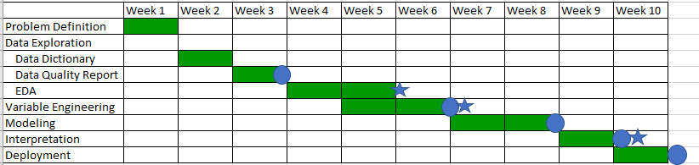

The project will be updated regularly in the following repository:

<https://github.com/akshayamrit/Udemy-Credit-Risk>